City Academy Whitehawk Nursery
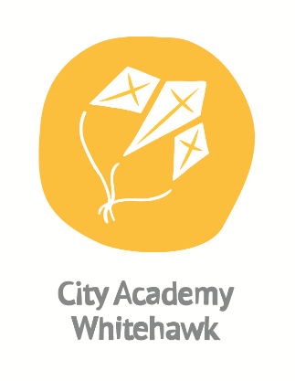
Initial Application Form
Please complete and return to the school office
Child’s Name

Preferred Name (if different)

Date of Birth

Gender

Languages Spoken

Names of Parents/Carers

Home Address

Telephone Number/s:
Email Address:

Details of any Medical Condition/Disability or Special Educational Need:

Please provide details of any siblings or other family members of your child who currently attend or work at City Academy Whitehawk.
Name:
Class:
Relationship:

When can my child start claiming nursery funding?
If your child’s third birthday is between: | Funding places start from:
1st April – 31st August | 1st September
1st September – 31st December | 1st January
1st January – 31st March | 1st April

Please inform us of the date you would like your child to start attending the nursery:
Month/year:

Sessions – Please tick which session/sessions you would like your child to attend. Please be aware we may not be able to offer your preferred sessions.
 | 3-4 Year EYEE Hours | Time | Please  Tick one
Hatchlings Class 1 | Monday  Tuesday  Wednesday | 9am-3pm  9am-3pm  8.45am-11.45am
Hatchlings Class 2 | Wednesday  Thursday  Friday | 12pm-3pm  9am-3pm  9am-3pm

Signature of parents/carers: Date:
_______________________________________________________________________________________________
If I/ we find I/we no longer need a place, I/we will notify the School as soon as possible.

