City Academy Whitehawk Nursery
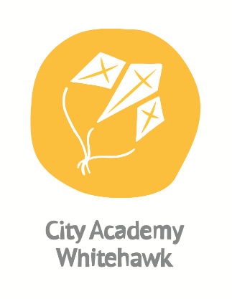

Tel: 01273 681377
cawadmin@auroraacademies.org

Welcome to City Academy Whitehawk. We are very proud of our school and everything we do is captured in the phrase:

“The Highest Expectations for All”.

We believe passionately in the potential for every child in our school to be supported, nurtured and challenged in order to allow each child to flourish into being the very best that they can be. We strive to provide an outstanding education to ensure that every child develops the self-belief and the skills that they need to have a successful and fulfilling life. To achieve this, we have the highest expectations for our staff, our parents/carers, our community and of course our children themselves.

We challenge ourselves to provide the best possible education and to really be a school that ‘goes the extra mile’ for our children and community. We are committed to ensuring that our children feel safe, understand what it means and why it is important to be healthy and know how to achieve this. We believe that central to achieving their very best, children need to be confident and highly skilled in the core subjects of reading, writing and maths.

At City Academy Whitehawk, we believe in six core qualities that all of our school community need to develop and demonstrate. We call these our ‘CAW Qualities’ and they are:

Collaboration
Aspiration
Resilience
Effort
Excellence
Respect

We will strive to ensure every child understands the importance of each quality and to become as confident in each as they can possibly be.

Our Nursery aims to:
- Provide a happy, safe, warm and stimulating environment for all children to play, learn and develop freely.
- Help children to develop responsibly for themselves and their actions and to become competent, confident, independent and cooperative individuals.
- Encourage children to have a positive attitude and respect for both themselves and other people.
- Promote positive relationships with parents/carers and work in partnership with them to provide high quality play and care for their children.
- Offer inclusive services that are accessible to all children in the community.
- Undergo regular monitoring and evaluation of our services to ensure that the nursery continues to meet the needs of children and parents/carers.

Our Nursery is committed to providing:
- Care and activities that put the needs and safety of children first.
- A programme of activities that is interesting, educational, stimulating and fun.
- Activities that promote each child’s social, physical, moral and intellectual development.
- Access to a variety of facilities and equipment under safe supervised conditions.
- A staff team that is experienced, well trained and properly supported.
- Services that meet the conditions of the Childcare Act 2006 and all other relevant childcare legislation, wherever they apply.
- An environment, where no child is bullied or suffers discrimination in any form.
- All staff are checked by the Disclosure and Barring Service (DBS) as part of the recruitment process.
Staff Ratio
Our ratio is in accordance with OFSTED:
3 years- 4 years 1:8/1:13 with EYP

Early Years Free Entitlement
All children are eligible to attend Nursery for 15 hours a week, for free. These hours are funded by the government and begin the term following the child’s 3rd birthday. Three and four year olds whose parents are working might be eligible to attend Nursery for 30 hours a week. Further information is available on request. If you believe you are eligible for your child to attend Nursery for 30 hours a week, please tick the boxes for both Hatchlings 1 and 2 on the Initial Application Form.

Settling in visits
All children are unique and the amount of time that a child takes to settle into our Nursery can vary enormously. Therefore, children will be given time to settle in at their own pace, so as to make them feel welcome, safe and confident in a new environment.
We encourage parents to help during this time. We will also visit the children in their home environment; this gives us a chance to meet the family and child before they start at the nursery. During this time we can answer any questions you may have and go through the contract and starting points.

Admission Criteria
Please refer to our Nursery Admissions Policy on our website or available from the school office.

Important
A completed application form does not guarantee a place at City Academy Whitehawk’s Nursery. If we are able to offer a place, we will confirm so in writing.
A place in the Nursery does not guarantee a place in the School.
Parents of children in the nursery MUST apply for a Reception school place through Brighton and Hove School Admissions.

