

**Year 3-4 Problem types**

**Logic Puzzles**

**Therapy Test 3**

# To support the therapy for

# Logic Puzzles

# **Commissioned by The PiXL Club Ltd.**

**October 2019**

This resource is strictly for the use of member schools for as long as they remain members of The PiXL Club. It may not be copied, sold nor transferred to a third party or used by the school after membership ceases. Until such time it may be freely used within the member school.

All opinions and contributions are those of the authors. The contents of this resource are not connected with nor endorsed by any other company, organisation or institution.

PiXL Club Ltd endeavour to trace and contact copyright owners. If there are any inadvertent omissions or errors in the acknowledgements or usage, this is unintended and PiXL will remedy these on written notification

© Copyright The PiXL Club Limited, 2019

**Therapy test 3**

**Y3-4 Problem types - logic puzzles**

1. Each of these shapes represents a number. What number does each shape represent?

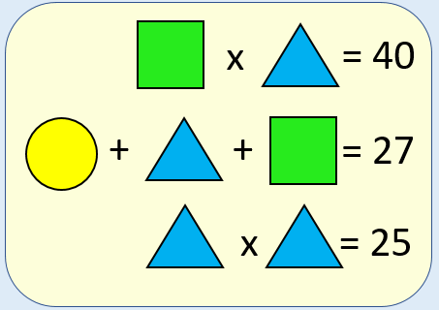

1. These four children each have a different topping on their jacket potatoes. Use the clues to work out who has each topping.

|  |  |  |  |  |
| --- | --- | --- | --- | --- |
|  | Tuna | Cheese | Beans | Chicken |
| Samuel |  |  |  |  |
| Lauren |  |  |  |  |
| Ella |  |  |  |  |
| Mason |  |  |  |  |

1. Mason and Lauren don’t like fish.
2. Ella and Mason are vegetarian so don’t choose to eat meat.
3. A girl chooses cheese and a boy chooses tuna.

3. Use the clues to work out what colour each shape is.

1. Orange is not next to purple.
2. Yellow is between purple and blue.
3. Green is not a triangle.
4. Yellow is on the right side of pink.