R1a Can discuss a range of books and texts that they have read, explaining key information and giving their opinion about it
Test 3

Commissioned by The PiXL Club Ltd.
May 2018
This resource is strictly for the use of member schools for as long as they remain members of The PiXL Club. It may not be copied, sold nor transferred to a third party or used by the school after membership ceases. Until such time it may be freely used within the member school.
All opinions and contributions are those of the authors. The contents of this resource are not connected with nor endorsed by any other company, organisation or institution.
PiXL Club Ltd endeavour to trace and contact copyright owners. If there are any inadvertent omissions or errors in the acknowledgements or usage, this is unintended and PiXL will remedy these on written notification.

© Copyright The PiXL Club Limited, 2018
Can discuss a range of books and texts that they have read, explaining key information and giving their opinion about it Test 3

- Give one feature of each of the story types listed below – the first one has been done for you.

Story type | Feature
Adventure | friendships and teamwork defeat villains
Science fiction

Historical

Myths and Legends

- Give three features of a non-fiction book that would help you to locate the information that you wanted quickly.

- _________________________________

- _________________________________

- _________________________________

- Think of either a story or a non-fiction book that you have read recently – it could be one that you have been reading at home, one from the library or one to do with your learning at school.
Write your opinion of the book below.

__________________________________________________________________

__________________________________________________________________

__________________________________________________________________

__________________________________________________________________

Y4 R5a Can discuss word meanings, based on their existing vocabulary knowledge Test 3 - ANSWERS

Qu. | Answer
1 | 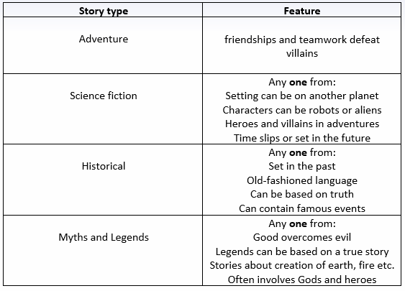
2 | contents page, index, sub-headings
3 | Any answer which gives a sensible opinion of a book that they have read using any of the key features or sentence stems below.  Story Non-fiction  I enjoyed this book because … My favourite character was … because … The most exciting part of the story was … The reason I think this is … I would recommend this book because … A contents page An index A glossary Headings and sub-headings Diagrams and pictures Bullet points Captions Websites

