**M4a Test 2**

1. A boat can safely carry 145 kilograms.

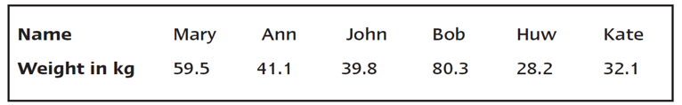

Work out if the boat can **safely** carry Mary **and** Bob.

* 1. Some children go camping. It costs **£2.20** for each child to camp each night. How much will **each child** have to pay for the **6** nights?
  2. There are 78 children. Each tent takes up to **6** children. How many tents will be needed?

1. Rashid, Earl and Jenny go to a football match. The cost for each of them is £9.50. What is the total cost for all three of them?