**M4a Test 3**

1. A group of friends decide to take part in a sponsored walk.
   1. Ann is sponsored for £6.20 each lap. She does 8 laps. How much money does she raise?
   2. Emma wants to raise £100. She is sponsored for £7.50 for each lap. What is the least number of whole laps she must do?

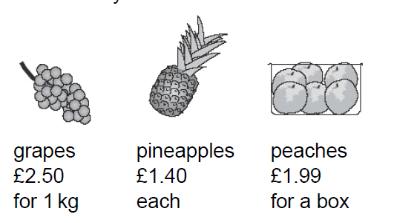

* 1. Amir buys 2 pineapples and a box of peaches. How much does he pay?
  2. He pays with a £10 note. How much change does he get?

1. For his birthday, Simon’s grandmother says she will give him **four times** the amount he has in his Savings Account. Simon has **£23.64** in his account. How much will his grandmother give him?