

# **A2 R2a. Can explain what words suggest about a given subject (and offer synonyms as alternatives to words read to demonstrate understanding)**

# **Test 2**

**Commissioned by The PiXL Club Ltd.**

**November 2019**

**This resource is strictly for the use of member schools for as long as they remain members of The PiXL Club. It may not be copied, sold nor transferred to a third party or used by the school after membership ceases. Until such time it may be freely used within the member school.**

**All opinions and contributions are those of the authors. The contents of this resource are not connected with nor endorsed by any other company, organisation or institution.**

**PiXL Club Ltd endeavour to trace and contact copyright owners. If there are any inadvertent omissions or errors in the acknowledgements or usage, this is unintended and PiXL will remedy these on written notification.**

© Copyright The PiXL Club Limited, 2019

# **Teachers’ Notes and Guidance for the A2 Reading Therapy Tests**

The intention of the A2 therapy tests is to provide teachers with assessment information regarding the security of the taught concept or skill. Prior to administering the test, it is recommended that the corresponding therapy test for Expected Standard has been given to the pupil, to ensure there are no gaps which could preclude the awarding of Above Expected Standard. Once the pupil is deemed secure at the Expected Standard for a given skill, the A2 Therapy tests can be used to determine the depth of a pupil’s understanding about a specific skill.

The therapy test has been written to check that the concept is both understood and can be applied in a range of contexts. Each therapy test may be presented slightly differently to reflect the nature of the skill it is assessing.

Teachers should consider the outcomes in the context of pupils’ overall attainment. It is possible that oral responses may differ from those recorded, in which case, therapy tests can be edited and adapted to give pupils practice at applying a specific skill in a test-style context.

Information from the A2 therapy tests should be used to support teachers in updating the A2 PLC, where appropriate.

* An A2 reader will be able to confidently decode any text but may not understand higher level concepts, such as extended inference responses, comparison within a text and justifying their answers using supporting evidence.
* Skimming and scanning skills are included on the A2 PLC for reading. As a text gets more complex in meaning, it will become more difficult for children to skim for general content and scan for specific information. These skills need continuous practice as texts and questioning become more challenging.
* Children will be challenged through A2 therapies both by the complexity of the text and the level of questioning. Their ability to answer 2 and 3 mark questions will be tested throughout.

# **A2 R2a. Can explain what words suggest about a given subject (and offer synonyms as alternatives to words read to demonstrate understanding)**

*\* The Iceland text can be found on Primary Wise by typing ‘Model Text 1 Iceland Brochure’ into the search bar.*

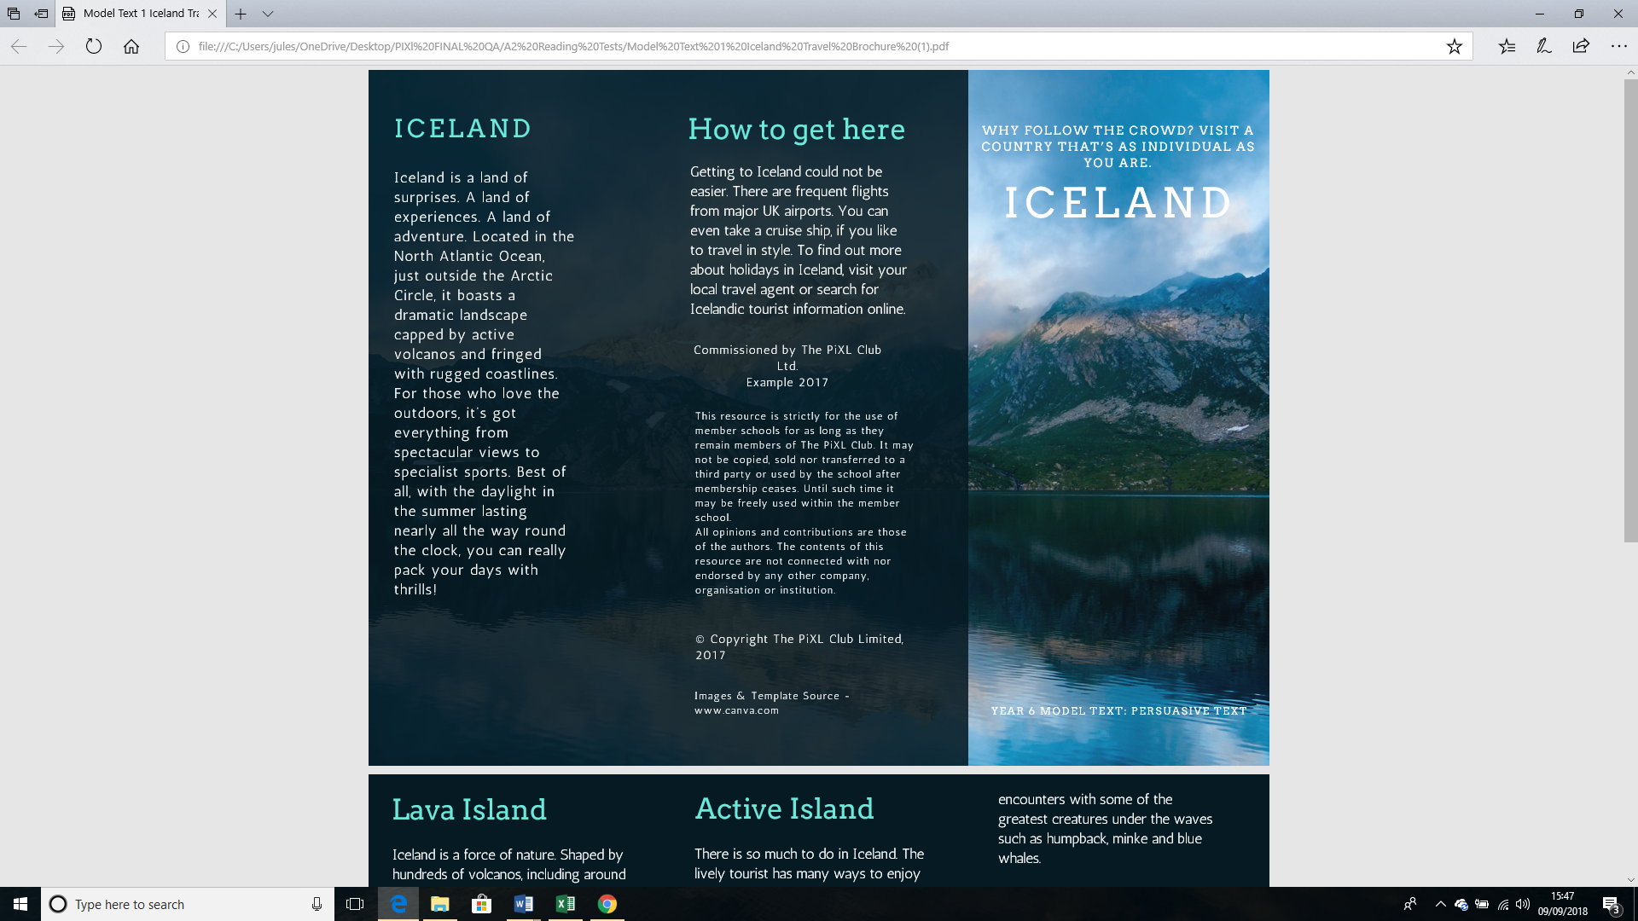

1. ‘*It boasts a dramatic landscape…’*

What do these wordssuggest about Iceland’s landscape? **(1 mark)**

___________________________________________________________________________

___________________________________________________________________________

2. *‘Fringed with rugged coastlines.’*

What do these words suggest about Iceland?

Give **two** points. **(2 marks)**

___________________________________________________________________________

___________________________________________________________________________

___________________________________________________________________________

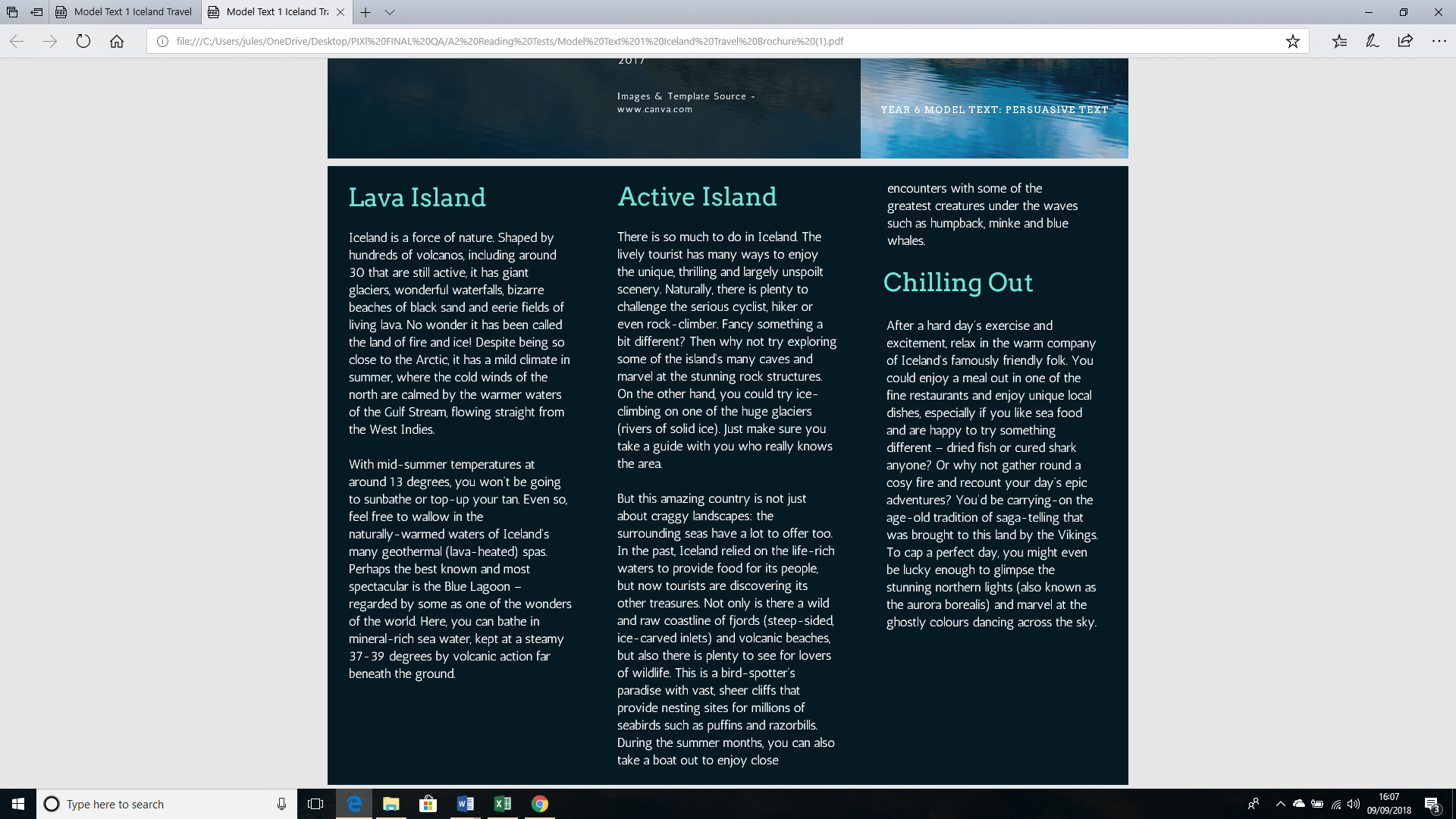

3.

__________________________________________________________________________________

__________________________________________________________________________________

__________________________________________________________________________________

__________________________________________________________________________________

___________________________________________________________________________

3. ‘*…feel free to* ***wallow*** *in the naturally-warmed waters of Iceland’s many geothermal (lava-heated) spas.’*

What does the word ***wallow*** suggest about what you might do in the geothermal spas? **(1 mark)**

___________________________________________________________________________

4. ‘*Just make sure you take a guide with you who really knows the area.’*

What do these words suggest about ice climbing on the glaciers? **(1 mark)**

___________________________________________________________________________

___________________________________________________________________________

# **A2 R2a. Can explain what words suggest about a given subject (and offer synonyms as alternatives to words read to demonstrate understanding)**

**Answers:**

1. Award 1 mark for reference to any of the following:

That it is:

* exciting
* impressive/ spectacular/striking
* large/ there is lots of it/lots going on
* significant
* striking/ vivid/ breath taking/amazing/stunning/sensational

2. Award 1 mark for reference to any of the following up to a maximum of 2 marks:

* Fringed means edge/surround/encircle so it means that there is coastline all around Iceland.
* Jagged means: rough/ uneven/bumpy/rocky/stony/jagged
* The coastline surrounds Iceland and it is rough.

3. Award 1 mark for reference to any of the following (and other synonyms):

* lie around
* splash about
* luxuriate
* relax
* take pleasure

4. Award one mark for reference to any of the following:

* that it could be dangerous
* you could get lost